**Screening and identification of antibiotic producing bacteria from Hussain Sagar Lake for the control of microbial pathogens**

**Abstract**

Antibiotics are the most important bioactive compounds for the treatment of infectious diseases. But now, because of the emergence of multi-drug resistant pathogens, there are basic challenges for effective treatment of infectious diseases. Antibiotics are most important commercially used secondary metabolites, produced by many microorganisms *i.e.*, bacteria and fungi and employed in wide range. Most important antibiotics used today are of microbial origin. The emergence of antibiotic resistance and need of broad spectrum antibiotics is in focus and in demand. Thus, due to the burden for high frequency of multidrug resistant pathogens in the world, there has been increasing interest for searching effective antibiotics from microorganisms in diversified ecological niches. In the present study, the randomly selected waste effluents samples were taken from Hussain sagar lake areas for isolation of bacteria. For the isolation of bacteria from environmental samples requires an understanding of the potential waste sample areas and environmental factors affecting their growth and different potential areas such as waste effluents samples were important activities for isolation of different types of potent antibiotic producing microorganisms. In this work we isolate the antibiotic produced bacteria from Hussain Sagar Lake and we checked the antibiotic activities against pathogenic bacteria and plant phytopathogens. Potential isolate was identified by using morphological and biochemical tests. This study suggests that *Actinomycetes* have the potential to produce antibiotics and can be used to control microbial growth in future. This work may provide potential information on the antibiotic production and further be used for the control of microbial strains.

**1. INTRODUCTION**

The term antibiotic appeared as early as 1928 in the French microbiological literature as antibiosis. The phenomenon of antagonism between living organisms was frequently observed even since 1877, when Pasteur and Joubert noticed that aerobic bacteria antagonized the growth of *Bacillus anthracis*.

However, the world in its present restrictive meaning, “a chemical substance derived from microorganisms, which has the capacity of inhibiting growth and even destroying other organisms in dilute solutions” was introduced by Selman and Waksman in 1942. In 1940 Waksman had forecasted, “We are finally approaching a new field of domestication of microorganisms for combating the microbial enemies of man of his domesticated plants and animals. Surely microbiology is entering a new phase of development. During the 1960s, the phase of discovery of antibacterials slackened, but efforts were then made to research also for antifungal, antimycoplasmal, antispirochetal, antiprotozoal, antitumor, antiviral and antiphage compounds, as well as for antibiotics for non-medical uses such as antioxidants. (A.Waksman, Dr.Selman *et al.,*1954 ).

The problem of bacterial resistance to antibiotics had evolved and new compounds or derived from the known antibiotics had to be found to replace existing ones.

**1. 1 Progress of trends in Antibiotic Search**

The continuing success of a biotechnologist in the search of microbial metabolites as antimicrobial compounds (antibiotics) is useful in combating human, animal and plant diseases for stimulating the belief that microorganisms constitute an inexhaustible reservoir of compounds with pharmacological, physiological, medical or agricultural applications (John E. Smith *et al.,*1989 ).

Antibiotics continue to play a crucial role in the development of tissue culture techniques and basic screenings, primarily in biochemistry, molecular biology, microbiology and genetics including genetic engineering and to a lesser extent, pharmacology and organic chemistry (John Bu’ Lock *et al.,*1987 ).

In the research for new antibiotics, the leading position of Japan, United States and England remains unchanged. Recently, the marketing products have been in number of analogs, minor modifications of earlier known antibiotics. Mainly as a result of novel strain isolation and selection methods, refined compound isolation and characterization procedures and *in vivo* assay systems, completely new compounds still emerge at a slower pace. Though chemical derivatives or bioconversions of antibiotic offer potential to yield more useful compounds, finding new antibiotics remains the most desirable objective.

**1. 2 Goals of Antibiotic Research**

The study and development of antibiotics certainly share some of the same aims as other areas of biotechnology. For example, it is always desirable to try to improve the yield of an antibiotic during fermentation and subsequent processing steps (Erick J Vandemme, Marcel Dekker *et al.,*1948).

A very large fraction of antibiotic research is directed towards development of new agents, because :

1. Many microorganisms, including most fungi and viruses, do not have truly effective and safe antibiotics.

2. Some bacteria, such as *Pseudomonas aeruginosa*, also are intrinsically resistant to most antibiotics.

3. Pathogenic bacteria are acquiring or developing resistance to existing antibiotics in correlation with the level of use of these antibiotics to treat them.

4. Many potentially important antibiotics have associated nephrotoxicity and ototoxicity.

5. Most of the existing antibiotics are more costlier. Because of the above reasons, research in newer antibiotics and optimization of yield and productivity of antibiotics is still important.

**1. 3 *Actinomycetes***

The *Actinomycetes* are gram positive, high G+C (>55%) organisms that tend to grow slowly as branching filaments. Many *Actinomycetes* will grow on the common bacteriological media used in the laboratory, such as nutrient agar, trypticase soy agar, blood agar, and even brain-heart infusion agar. *Actinomycetes* encompass a wide range of bacteria. They have universal occurrence and play an active part in the cycle of nature (Egorov NS *et al.,*1992).

*Sporoactinomycetes* require special media to allow differentiation and development of characteristics spores and pigments. For example, the pale, shiny, hard colonies of a *Streptomyces* species on nutrient agar can be transformed into bright yellow colonies with a powdery white aerial mycelium and spirals of arthrospores when the organism is subcultured onto a more suitable growth medium, such as oatmeal or inorganic salts starch agars.

*Actinomycetes* show outgrowths from a spore or fragments of mycelium (Colony-forming units, CFUs) develop into hyphae that penetrate the agar (substrate mycelium) and hyphae that branch repeatedly and become cemented together on the surface of the agar to form a tough, leathery colony. The density and consistency of the colony will depend on the composition of the medium. *Nocardioform* *actinomycetes* exhibit fragmentation; the hyphae break up into rods and cocci, thus leading to soft or friable colonies. In strains of certain genera (e.g. *Streptomyces*), the colony becomes covered with aerial mycelium: free, erect hyphae surrounded by a hydrophobic sheath that grow into the air away from the colony (FA.Skinner,G.Syker *et al.,*1973). *Actinomycetes* grow slowly. A branching mycelium growing at the surface of transparent agar can be seen with the aid of a microscope after 24 hours, and visible colonies may appear in 3-4 days, but mature aerial mycelium with spores may take 7-14 days to develop, and some very slow growing strains may require up to 1 month’s incubation.

The saprophytic *Actinomycetes* are oxidative and may grow poorly when the air supply is restricted. Actinomycetes can grow in broth but need to be cultivated under specialized conditions. The growth of *Streptomycete* in a stationary broth tube is usually restricted to a surface pellicle and perhaps cottony sediment, leaving the broth quite clear. Liquid cultures require considerable aeration and agitation to give the suspended growth. Tubes and flasks must be incubated on a shaker at high speeds (e.g. 200 – 250 rpm) to give the supply of oxygen and mixing necessary for maximum growth. Even, diffuse mycelial growth may require the higher agitation and mixing rates achieved by baffles or springs (G.Edward, Jaff.Bergey’s 9th edition).

The morphology of an actinomycete growing on agar can provide useful and rapid clues to its identity, but viewing isolated colonies can give little worthwhile information. Morphological

characters are still widely used for characterizing genera, for example, the presence or absence of spores on the substrate mycelium or the formation of zoospores in specialized spore vesicles or sporangia. The ability to produce motile spores is more widespread in the actinomycetes. Preservation of both sporing and non-sporulating *Actinomycetes* can be achieved by freeze drying or storage in liquid nitrogen. Freezing suspensions in 20% (v/v) glycerol at -20°C to -

40°C has proved to be a very useful method in a busy laboratory. Filament may fragment into irregular sized elements (0.5 – 1.0 m in diameter) or remain stable and produce arthrospores. Spores are produced singly, in chains of various lengths, or in sporangia. Spores are usually non-motile, but some genera produce flagellate spores. Some genera that do not produce branching filaments are phylogenetically related to this group. Genera of actinomycetes are distinguished on the basis of their morphology and marker chemical constituents of the cell wall, membranes and whole cell hydrolysates (Marcel Dekker, William R. Strohl *et al.,* Vol.82).

*Actinomycetes* are mainly aerobic, but some genera are facultative or obligately anaerobic. *Actinomycetes* are ‘chemoheterotrophic, using a wide variety of energy sources, including complex polymers. Mainly free living in a wide range of habitats (water and soil). Some are pathogens for human, animals or plants.

**1. 4 Generic groups of *Actinomycetes***

***1) Nocardioform*** actinomycetes***:-***

This is a heterogenous group which forms filaments and fragment into shorter elements. Aerial growth is formed by some genera and may produce chains of spores. Genera are distinguished primarily by well chemotypes, presence or absence of mycolic acids and other chemical characters.

Subgroup 1: Mycolic acid-containing bacteria (Genus – *Gordona, Nocardia, Rhodococcus* and *Tsukamurella*)

Subgroup 2: *Pseudonocardia* and related genera (Genus – *Actinobispora, Actinokineospora, Actinopolyspora, Amycolata,* *Pseudoamycolata, kibdelosporangium, Saccharomonospora*

and *Saccharopolyspora*).

Subgroup 3: *Nocardioides* and *Terrabacter*

Subgroup 4: *Puomicromonospora* and related genera (Genus – *Jonesia, Oerskovi*

***2) Genera with multilocular sporangia:***

These genera form filaments that divide by longitudinal andtransverse septa. This produces large number of coccoid-likeelements, which may be motile (*Dermatophilus, Geodermatophilus*)or non-motile (*Frankia*).

***3) Actinoplanes:***

Stable filaments are formed, with little or no aerial growth. Motile spores are produced in sporangia. (*Actinoplanes,* *Ampullariella, Dactylosporangium, Pilimelia*) or non-motile spores are produced singly (*Micromonospora*) or in chains (*Catellatospora*). Cell wall contains meso-DAP and glycine, arabinose and xylose are found in whole cell hydrolysates.

***4) Streptomycetes and related genera:***

A heterogenous group, all of which have cell wall containing LDAP and glycine. Stable filaments are formed and may produce extensive aerial growth with long spore chains (*Streptomyces,* *Streptoverticillium*). Other genera (*Intrasporangium, Kineospora,* *Sporichthya*) produce little or no aerial growth and have a variety of spore forms.

***5) Maduromycetes:-***

Stable filaments are formed and produce spore bearing aerial growth. Short chains of non-motile arthrospores are produced by *Microbispora* (two spores), *Microtetraspora* (four spores), and *Actinomadura* (varying number). Other genera produce spores in sporangia which are motile (*Planobispora, Planomonospora,* *Spinillospora*) or non-motile (*Streptosporangium*). The cell walls contain meso-DAP, and cell hydrolysates contain madurose.

Subgroup 1: *Streptosporangium* and related group (Genus – *Microbispora, Microtetraspora, Planobispora, Planomonospora,* *Spirillospora, Streptosporangium*).

Subgroup 2: *Actinomadura*

***6) Thermomonospora and related genera:***

Stable filaments are formed and produce aerial growth bearing spores that are single (*Thermomonospora*), in chains (*Actinosynnema, Nocardiopsis*), or in sporangia-like structures (*Streptoalloteichus*). The cell wall contains meso-DAP, but not characteristic amino acids or sugars in whole cell hydrolysates.

***7) Thermoactinomycetes:***

This comprises only one genus, *Thermoactinomycetes*. The stable filaments produce aerial growth. Single spores (which are endospores) are formed on both aerial and vegetative filaments. All species are thermophilic. The cell wall contains meso-DAP but not characteristic amino acids or sugars.

***8) Other genera:-***

This group comprises three genera (*Glycomyces, Kitasatosporia* and *Saccharothrix*) that cannot at present be assignedto other groups. They all produce aerial growth bearing chains ofspores.

**1. 5 Source of Antibiotic Producing Microorganisms**

Antibiotics are produced by many microorganisms in various ecological conditions. Producers of antibiotic can be found in rivers, lakes, decaying plants and animal remains etc. but majority of microorganisms that produce antibiotic inhabits soil (Casida LE, Wiley Easter *et al.,*1984).

**Role of Actinomycete in the field of Research**

Antibiotics are the best known products of actinomycete. Over 5000 antibiotics have been identified from the culture of gram positive, gram negative organisms and filamentous fungi, but only 100 antibiotics have been commercially used to treat human, animal and plant disease. The genus *Streptomycete* is responsible for the formation of more than 60% of known antibiotics. While further 15% are made by number of related *Actinomycete, Micromonospora,* *Actinomadura, Streptoverticillium* and *Thermoactinomycetes*. Many of the microbial products including antibiotics are considered to be ‘Secondary metabolites’ because they seem to have no direct role in those aspects of metabolism which support necessary functions in the cell namely energy production, growth and reproduction. There is a great structural variety among the secondary metabolites but organisms also have the ability to produce closely related metabolites. Some are antimicrobially active and some are not. Antibiotics, because of their industrial importance, are the best known products of *Actinomyctes*. *Streptomycete* is responsible for the formation of more than 60% of known antibiotic while further 15% are made by number of related *Actinomycete*– *Micromonospora,* *Actinomadura, Stretoverticillium* and *Thermoactinomycetes*.

The selection of superior producing microorganisms was earnestly pursued by Weinstein et al. They thoroughly screened microorganisms of the genus *Micromonospora* which had rarely been studied and found gentamicin and several other antibiotics. With this work as a turning point, studies shifted to methods for effectively isolating actinomycetes other than *Streptomyces* which are less frequent in soil. Rare actinomycetes were found to produce many new antibiotics. However, since rare actinomycetes do not usually produce antibiotics abundantly and grow slowly, research on and development of they are difficult (Brun YV, Skimkets LJ *et al.,*2000).

1**. 6 Hussain Sagar Lake**

Hussain Sagar Lake was built in 1562 during the reign of the Qutb Shahi dynasty at Golkonda fort. It is an artificial lake built on a tributary of River Musi. The lake joins the cities of Hyderabad and Secunderabad besides adding an aesthetic appeal to the twin cities. The lake water was utilized for irrigation and drinking water needs from 1884 to 1930. The total catchment area of the lake is 240 square kilometres (93 sq mi). Through four main feeder nalas named Picket Nala, Kukatpally Nala, Banjara Nala and Balkapur Nalla, wastewater from the catchment area reaches the lake. Till 1930s, the lake was the major source of water supply to the population of Hyderabad and later on it turns into wastewater basin as the lake has gradually started receiving sewage and industrial effluents through the feeder nallas. The Picket Nalla discharges mostly domestic sewage throughout the year into the lake from the north-eastern side. Similarly the Banjara Nalla (from north-western side) and Balkapur Nalla (from western side) discharge mostly domestic sewage into the lake. The Kukatpally Nalla was seen to be discharging a mix of domestic sewage and industrial effluents into the lake from the northern side. This practice of discharging municipal sewage, industry effluents and storm-water from over 240 square kilometres increased the content of organic matter, nitrogen and phosphorus. This suspended organic matter, rich in nutrients, caused eutrophication that allowed growth of algal blooms and water hyacinth.

Sewage and industrial wastewater contain high amounts of complex organic matter which is mainly in the form of proteins and lipids. The biomass that reduces the complex content of the sewage is the activated sludge, biological flocs mainly composed of saprotrophic bacteria, and some protozoa and small metazoans. Microorganisms not only take up some small molecules for intracellular metabolism but also enzymatically hydrolyze a large fraction of the organic matter through a series of hydrolytic reactions to smaller units, which can be taken up by the bacterial cell uptake system. Previous research indicated that activated sludge is a good source for studying and discovering proteases which play a vital role in the extracellular catabolism of organic matter in activated sludge (A.Beswick DI Kurtboke, *et al.,* 1993). They have diverse functions ranging from catabolism to protein post-translational modification and regulation of biological processes. However, up to 80–90% of the microorganisms detected inactivated sludge by 16S rRNA genes based on molecular taxonomic studies cannot be cultured using standard cultivation techniques, leaving a potentially valuable resource largely unexplored.

Today both academic and industrial interest in soil bacteria (due to their several advantages over other microorganisms) is on the rise, in search of deriving these unique biologically active metabolites and novel commercially important products from them. Bacteria are present in diverse ecological habitats. They are considered highly valuable as they are used in fermentation processes, much as brewing, baking, cheese and butter manufacturing, chemical manufacturing such as ethanol, acetone, organic acid, enzymes, perfumes etc., microbial mining and they produce various antibiotics, vaccines, steroids as well as other therapeutically useful compounds with diverse biological activities (RJ Strobel, S.Parekh, VA Vinci *et al.,* 2000). Hence there is an immense possibility to screen effective bacterial strains from waste dump sites with valuable applications. To cope up with the demand for new organisms with properties of production of unique molecules for antibacterial properties there have been a constant effort in isolating novel bacteria from diverse environment. Therefore, the objective of the present study was to isolate and screen antibacterial metabolite producing bacteria from Hussain Sagar Lake in Hyderabad.Telangana. The outcome of this finding may be important to give direction for researchers and for future treatment of multidrug resistant human pathogens.

**OJECTIVES**

1. To isolate the microorganisms capable of producing antibiotics.

2. To test the microorganisms for anti-bacterial & antifungal activity

3. To know the morphology and characterization of the positive strain.

4. To extract the antibiotic from the positive strain.

5. To determine the structural component of the antibiotic produced.

**2. REVIEW OF LITERATURE**

| Author | Year | Work |
| --- | --- | --- |
| Erick J. Vandemme, Vol. 22, Marcel Dekker | 1948 | Biotechnology of Industrial Antibiotics. |
| Gcos Andrews, J.Miller | 1949 | Study on penicillins and other antibiotics. |
| Selman A. Waksman. | 1953 | The *Actinomycetes*. |
| FA Skinner, G. Syker | 1973 | *Actinomycetals:* Characteristics and practical importance. |
| Satoshi Omura, Yuzura Iwai. | 1981 | Cultural conditions for screening of new antibiotics. |
| LC.Vinning, S.Chatterjee. | 1981 | Nutrient utilization in *Actinomycetes*. |
| Casida LE | 1984 | Industrial Microbiology, 3rd edition. |
| John E. Smith | 1987 | Perspective in biotechnology and applied microbiology. |
| Alfonso Mendoza, Juan Soliveri,Maria-Enriqueta Arias. | 1988 | Effect of different nutrients on the production of polyene antibiotics PA-5 and PA-7 by *Streptoverticillium spp* 43/16 in chemically defined media. |
| C. Edwards, M. Dawson, PDA James. | 1991 | The effects of temperature, Ph and growth rate on secondary metabolism in *Streptomyces thermoviolaceus* grown in a chemostat. |
| Egorov NS | 1992 | Antibiotics – A Scientific Approach. |
| CA Yallop, JP.Burden, JC.Ensign, P.Normand**.** | 1993 | Physiology of *Actinomycete* genera. |
| Hall.SJ, Stanbury PF, Whitaker.A. | 1995 | Antibiotic Diversity |
| Yoshika Hosoya, Hideyaki Muramatsu | 1998 | Mutations enhances antibiotic production in bacteria. |
| RJ Strobel, S. Parekh, VA Vinci | 2000 | Improvement of microbial strains and fermentation processes. Applied Microbiology and Biotechnology |
| Brun YS, Skimkets LJ. | 2000 | Prokaryotic development. |
| Haifeng hu and Kozo Ochi | 2001 | Improving the productivity of antibiotic producing strains by inducing combined resistant mutations. |
| KozoOchi, Susumu Okamoto, Yoshiko. | 2003 | Development and antibiotic overproducing strains by site directed mutagenesis. |
| Jun Xu, Haifeng Hu, Noboru Otake. | 2003 | Innovative approach for improvement of an antibiotic. |
| R. Gesheva, V. Gesheva, V. Ivanova | 2005 | Effects of nutrients on the production of AK-111-81 macrolide antibiotic by *Streptomyces* *hygroscopicus*. |

**3. MATERIALS & METHODS**

**3. 1 Collection of water & soil samples from different places in hussain sagar**

The water and water & soil samples were collected from different places, in and around Hussain Sagar, Hyderabad. The soil samples were dried separately at 37° C for 1 hr in hot air oven. Then they were cooled to room temperature. 1 gm of each soil sample was added to a conical flask containing 100 ml of sterile water. The flask was shaken for 30 minutes in orbital shaker, incubated at 27° C. The flask was considered as stock culture. In this work water samples are used directly as stock cultures.

**3. 2 Screening of *Actinomycetes*, capable of producing antibiotic by crowded plate technique**

A series of culture tubes containing 9 ml of sterile water were taken. From the stock culture, 1 ml suspension was transfered aseptically to the 1st tube (10-1), mixed well. From the 1st tube, 1 ml of suspension was transferred into 2nd tube (10-2), mixed well. Similarly, dilutions up to 10-5were made (serial dilution technique). 0.1 ml of suspension from each culture tube was spread on sterile soyabean casein digest medium (SBCD) plates or *Actinomycetes* isolation agar (AIA) medium plates and starch-casein agar medium plates aseptically in Laminar-Air flow bench. The plates were incubated at 37 °C (±2°C) for 24 hours. The plates were observed intermittently during incubation.

After 24 hours, a whitish pin-point colony which is the characteristic feature of *Actinomycete* with clear zone of inhibition around it, were seen. The pinpoint colonies with inhibitory or clear zone of inhibition were selected and purified into *Actinomycetes* agar slants. The selected strains were further purified by multiple streaking methods. The stock cultures of each selected strain was prepared and maintained in *Actinomycetes* agar slants at +4°C. Based on the growth of the organism 6 isolates were selected, maintained and used for further studies.

**3. 3 Characterization of isolates:**

**3. 3. 1 Gram staining:**

**3. 3. 2 Taxonomical characterization:**

**3. 3. 2. 1 Test for Melanoid pigment formation**

The test for melonoid pigment was done to observe the production of pigments and also the excretion of pigments into the media. Pigment production is one of the most significant properties of *Actinomycetes.* Most of the soil & water *Actinomycetes* produce melanin pigments in Waksman medium. Many pigments are produced on synthetic media which resulted in designation of many forms on the basis of pigment character such as presence of pigment in the vegetative or in aerial mycelium or distributed in and around the colony or dissolved in the medium. These pigments vary greatly in nature. It depends on the composition of different media, condition of growth and age of culture. Thus, pigment production is one of the easily recognizable characteristic of *Actinomycetes,* when media of known composition and definite conditions of culture are used. The sterile slants of Waksman media were prepared in culture tubes. Then, the isolates were streaked by simple streak method on the slants aseptically and incubated for 96 hours at 27 °C. During the period of incubation, the melanin pigment formation was observed at every 12 hour of interval for 96 hours.

**3. 3. 2. 2 Test for Nitrate Reduction**

*Actinomycetes* are have the ability to reduce nitrate to nitrite. On the basis of nitrate reduction property, they are divided into three groups:

a) The *Actinomycetes* which gives little or no reduction

b) The *Actinomycetes* which gives moderate reduction

c) The *Actinomycetes* which gives strong reduction

By considering the above property of *Actinomycetes,* the soil isolates were evaluated by using ‘organic nitrate broth’. 10 ml of sterile organic nitrate broth for each soil isolate was prepared. Then loopful of inoculum of soil isolates was added to the broth aseptically and incubated at 37°C for 24hr . Its nitrate reduction property was observed by using, 2 solutions they are:

A) Naphthalene solution

B) Sulfonilic acid solution

To the broth under examination, 2 drops of reagent (A) and 2 drops of reagent (B) were added. A positive reaction shows pink-red color.

**3. 3. 2. 3 Gelatin Liquefaction**

Soil *Actinomycetes* can hydrolyze gelatin by its exoenzymes. The protein gelatin is hydrolyzed by exoenzymes secreted by most of the soil isolates. The nutrient gelatin medium employed in this experiment will support the growth of most microorganisms. The solid character of the medium depends upon the gelatin remaining in the gel state. Many microorganisms produce exoenzymes that are capable of hydrolyzing gelatin and liquefying the nutrient gelatin medium. The sterile slants of nutrient gelatin agar were prepared. The isolates were inoculated into individual tubes of sterile nutrient gelatin slants by stab culture method. The inoculated tubes were kept at room temperature for 2 days.

**3. 3. 2. 4 Test for Amylolytic activity by starch hydrolysis**

Amylolytic activity of soil isolates were studied by using starch agar medium. Most of the soil *Actinomycetes* have the ability to hydrolyze starch rapidly by the action of amylolytic enzymes. The sterile slants of starch agar media were prepared. The soil isolates were streaked on the slants by simple streak method aseptically, and incubated for 24hr at 37°C. Amylolytic activity was observed by using iodine solution which indicates the hydrolysis of starch.

**3. 3. 2. 5 Carbohydrate Assimilation Test**

Type of carbohydrate source utilized by *Actinomycete* is an important biochemical property for the identification of *Actinomycete*. Assimilation is the utilization of carbon source by microorganisms in the presence of oxygen. Type of carbon source utilized by microorganism was identified by change in pH of the carbon utilization agar medium. Positive assimilation of growth indicated by color change from purple to yellow induced by bromocresol purple dye present in the medium. Sterile carbohydrate utilization agar with bromocresol purple dye was prepared. It is then inoculated with 1 ml of soil isolates and poured into sterile Petri dishes. After solidification, sterile discs containing 3% of different carbon sources such as dextrose, sucrose, starch, lactose, and maltose were placed aseptically on the surface of the medium and incubated at 37°C for 24hr.

Presence of growth around and under the discs along with change in color of the medium from purple to yellow indicates the type of carbon source utilized by isolated *Actinomycetes*.

**3. 3. 2. 6 Test for Proteolytic Activity**

**Milk coagulation and peptonization**

The proteolytic activity of the isolates was evaluated using pasteurized skimmed milk. The principle involved in this method is the digestion of milk proteins by *Actinomycetes*. The proteins which are present in skimmed milk, if get digested, gives positive reaction. All the isolates were inoculated aseptically into the different sterile culture tubes containing sterile pasteurized skimmed milk and incubated at 370c for 48 hours. The tubes were observed daily for 48 hours. The tubes were observed for following reaction.

a) Reduction of litmus paper

b) Change in medium color

These changes take place due to the digestion of milk proteins and change in the pH of the medium.

**3. 3. 2. 7 Hydrogen sulfide (H2S) production:-**

Numerous *Actinomycetes* are able of fermenting the proteins and produce hydrogen sulfide gas. Cysteine is one of the components of peptone contained in theH2S production medium. In the presence of cysteine desulfurase enzyme, cysteine loses the sulfur atom and it is then reduced by addition of H2 atom from water to form H2S. The sterile slants of hydrogen sulfide production media was prepared and streaked with soil isolates and incubated at 37°C for 2days. After incubation period, H2S production was observed by rotten egg smell and change in color of the medium to greenish brown, bluish black or black color.

**3. 3. 2. 8 Acid production**

The sterile glucose nutrient broth was prepared. It is then, inoculated by the soil isolates and incubated at 37°C for 1 day. Change in color was observed. Pink to yellow color change indicates the acid production.

**3. 4 Anti microbial activity of crude extract**

**3. 4. 1 Anti-bacterial activity:**

Nutrient agar plates are prepared and pathogenic bacterial lab cultures that is *Klebsiella pneumonia*, *Escherichia coli*  and *Staphylococcus* aureus were spread on the agar plates. Then the isolated cultures were placed using paper dip method and incubated for 24 hours. After 24hr of incubation clear zone of bacterial inhibition was observed around the *Actinomycete* isolates was measured and the diameter of the zone is recorded. Among the 6(A1-A6) *Actinomycetes* isolates which showed better anti- bacterial activity against the organisms are used for further study.

**3. 4. 2 Anti-fungal activity:**

Anti-fungal activity was detected by the dual culture method. Soil borne plant pathogenic fungi, *Sclerotium rolfsii* was grown on PDA medium. An agar block (five mm diameter) was cut from an actively growing (96 h old) fungal culture and placed on the surface of fresh agar medium at the centre of petri plate. A loopful of 24 h old culture of each *Actinomycetes* isolates was streaked in a straight line on one edge of a 90 mm diameter petri plate and plates were incubated at 37 °C. Inhibition zone between two cultures was measured after 5 days of incubation. Plates inoculated with the same fungus without *Actinomycete* served as control. Three replications were maintained for each and reduction in radial growth was measured and percent inhibition over control was calculated using the formula.



Where,

I = Inhibition % of mycelial growth (growth reduction over control)

C = Radial growth of fungus in the control plate (mm)

T = Radial growth of fungus on the plate inoculated with bacteria (mm)

**3. 5 Morphological characterization of positive A4 strain:**

**3. 5. 1 Gram staining**

**3. 5. 2 Cultural characterization:**

Morphological and cultural characters of the selected *Actinomycetes* strains were studied by inoculating the selected (A4) strain into sterile International *Streptomycetes* Project (ISP) media like:

A. Tryptone – Yeast extract broth

B. Oatmeal agar

C. Inorganic salts – Starch Agar

D. Glycerol – Aspargine Agar

E. Peptone – Yeast extract agar

F. Tyrosine Agar

G. Carbon utilization agar

1. Tryptone media was sterilized and poured into sterile petriplate. After solidification of the media, culture of the selected strain was streaked on the media surface by simple method aseptically and incubated at 37°C for 2days. Morphological characters such as colony characteristics, type of aerial hyphae, growth of vegetative hyphae, fragmentation pattern and spore formation were observed.

2. Oatmeal agar medium : *Actinomycetes* colonies form fungus like branched networks of hyphae. Fungi are multicellular heterotropic members of the plant kingdom that lack roots and stems and are referred to as thallophytes. They are larger than the bacteria and more complex in their morphology. The form of sporulation and the type of spore are important criteria in the identification of various fungi. Fungi are extremely successful organisms, as evidenced by their ubiquity in nature. Of the estimated 250,000 species, fewer than 150 are known as primary pathogens of humans. Identification and classification of fungi is primarily based on the morphologic differences in their reproductive structures. Fungi reproduce sexually or asexually or by both means. Sexual reproduction is associated with the formation of specialized structures that facilitate fertilization and nuclear fission, resulting in the production of specialized spores. Large, multicelled spores are called macroconidia, macroal euriospores or macrospores and are produced by aerial sporulation . Imperfect fungi are those in which no sexual phase has been demonstrated. The spores are produced directly or from the mycelium. Most of the fungi of medical importance belong to the imperfect group. Oat meal is a source of nitrogen, carbon, protein and nutrients necessary for the growth of fungi.

3. Starch agar medium: Starch Agar is used for cultivating microorganisms being tested for starch hydrolysis. Beef extract provides the nitrogen, vitamins, carbon and amino acids in Starch Agar. Starch reacts with Gram Iodine to give a blue color. Organisms hydrolyzing starch through amylase production will produce a clearing around the isolate while the remaining medium is blue. Agar is the solidifying agent. The starch agar media of 25 ml is prepared and autoclaved. Then allow the media to solidify, after that streak the test organism on the plate and incubate.

4. ISP Medium No. 5 (Glycerol Asparagine Agar Base) is based on the formulation described by Shirling and Gottlieb and is used for cultivation and characterization of *Streptomyces* species as recommended by the International *Streptomyces* Project. Being primarily soil inhabitants, Streptomyces are most commonly limited to causing Actinomycotic mycetoma. Areas more prone to formation of mycetomas are those that are frequently traumatized or that come into contact with soil. This medium provides consistent and reproducible characteristic features of *Streptomyces*. Glycerol serves as the carbon source while asparagine is the amino acid source for the growth of Streptomyces species. Trace mineral requirement of *Streptomyces* is satisfied by the trace salt solution, which contains various salts. Dipotassium phosphate buffers the medium.

5. Peptone yeast extract : ISP Medium No. 6 (Peptone Yeast Extract Iron Agar) is recommended by International *Streptomyces* Project for the cultivation and maintenance of *Streptomyces* species. Peptic digest of animal tissue, proteose peptone and yeast extract provide carbon, nitrogen, sulphur, vitamin B complex and other essential growth nutrients. Dipotassium hydrogen phosphate gives the medium good buffering capacity. Ferric ammonium citrate and sodium thiosulphate together serve as hydrogen sulphide indicator system.

6. Tyrosine Agar: Streptomyces and Nocardia species appear morphological similar in clinical material and in cultures. Nocardiosis, caused by Nocardia species, is a disease of man, most frequently encountered in patients who are severely immunosuppressed, and in animals. Streptomyces species may be differentiated from Nocardia species based on enzymatic hydrolysis of casein, tyrosine and xanthine. Clear zones in the medium surrounding colony growth indicate hydrolysis of the substrate present. International Streptomyces Project Medium No. 7 (Tyrosine Agar) is recommended for the isolation and enumeration of Streptomyces species. It is used for the differentiation of *Sreptomyces* species based on tyrosine utilization. The medium contains L-tyrosine, which is utilized by *Streptomyces* species. Zone of clearance around the colony indicates tyrosine hydrolysis. Trace elements provide essential factors for the growth of *Streptomyces* species. Inoculate the medium by streaking the isolate to be tested onto the agar surface with a sterile inoculating loop. The medium may need to be incubated for upto 3 weeks to allow positive hydrolytic reactions to develop. Examine plates at regular intervals for growth and hydrolysis.

**3. 6 Solvent extraction of antibiotic from A4 strain:**

1) 10 ml each of supernatant was taken in four separating funnel and extracted each with 10 ml of petroleum ether, ethyl acetate, n-butanol and methanol.

2) The organic solvent layer was concentrated and was subjected to antimicrobial studies.

3) Among four solvent layers, only ethyl acetate layer was found to possess antibiotic property. Then the remaining fermented broth was also extracted with ethyl acetate.

4) Then the ethyl acetate layer was concentrated at vacuum at 37°C to get dried product. It was further purified by extracting with various solvents in increasing polarity that is petroleum ether, n-butanol and methanol.

5) Antimicrobial activity of each solvent concentrate was checked. Methanol soluble part showed maximum antimicrobial activity. Methanolic extract was subjected to further purification.

6) The dried active product obtained from the concentration of methanolic fraction was dissolved in cold methanol which gave two portions, an amorphous powder precipitate and a soluble part. Both portions were again tested for its antimicrobial activity.

7) Only the amorphous portion showed antimicrobial property but soluble part did not show any activity.

8) Further, the purified amorphous product was analyzed for its purity by thin layer chromatography using different solvent systems.

**3. 7 Thin layer chromatography:**

The chromatographic parameter used in Thin Layer

Chromatography is as shown below:

Stationary Phase:

1. Silica gel used as stationary phase

Mobile Phase: 3 different types of solvents are used.

1. Methanol: Acetic acid (9.2: 0.8)

2. Methanol: Chloroform (9.4: 0.6)

3. N-butanol: Acetic acid: Water (4: 1: 0.5)

The TLC plates were prepared and spotted with the sample. Then, plates were developed by running the mobile phase and observed under UV light at 254 nm and also observed by developing spot with iodine vapour.

**3. 8 Physical properties of purified compound:**

The purified product was studied to determine its physical properties like

1. Color

2. Consistency

3. Melting point

4. Solubility

**3. 9 Structural identification of the extracted antimicrobial compound:**

The structure of the isolated compound was characterized as follows

**3. 9. 1 I.R. Spectroscopy:**

Purified antibiotic was subjected to IR analysis by using KBr pellets and the peaks obtained were observed and interpreted. The IR spectrum of the compound is shown in fig 4.15 and the data is recorded. The make of the instrument is IT Tracer-100 made by shimadzu for IR spectroscopy studies.

**3. 9. 2 NMR Spectroscopy:**

The purified compound was subjected to NMR analysis by proton resonance spectroscopy using NMR spectroscopy. Its spectrum was observed, interpreted and shown in the fig4.16 and the data is recorded. The make of the instrument is Mercury plus 300NMR spectrometer.

**3. 10 Anti- microbial activity of partially purified compound**

**3. 10. 1 Anti- bacterial activity:**

Nutrient agar plates are prepared and pathogenic bacterial lab cultures that are *Klebsiella pneumonia* MTCC 530, *Escherichia coli* MTCC 43 and *Staphylococcus* aureus MTCC 96 were spread on the agar plates. Then the extracted compound was placed using well method and different concentrations are used and incubated for about 24 hours. After incubation clear zone of inhibition was observed around the extracted compound and the diameter of the zone is measured and recorded.

**3. 10. 2 Anti- fungal activity:**

Extracted compound was dissolved in water and different concentrations (0.075 mg ml-1, 0.15 mg ml-1, 0.31 mg ml-1, 0.62 mg ml-1, 1.24 mg ml-1, 2.5 mg ml-1and 5 mg ml-1) were tested for antifungal activity. For testing antifungal activity, an agar plug of actively growing fungal culture was placed in the center of the plate. Then, wells were made (using sterilized agar borer), 2 cm away from the center where fungus was placed and different aliquots (as mentioned above) of extracted compound were added in separate wells and incubated at 37°C for 24 h to 96 h water was used as control. The inhibition percentage (I %) was calculated using the following formula



Where,

I = Inhibition % of mycelial growth (growth reduction over control)

C = Radial growth of fungus in the control plate (mm)

T = Radial growth of fungus on the plate inoculated with bacteria (mm)

**4. RESULTS & DISCUSSION**

**4. 1 Collection of the samples:** Different samples were collected from hussain sagar lake.

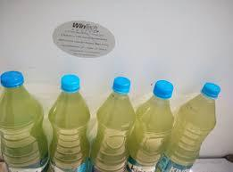

**Fig 4. 1 Hussain sagar water collected in bottles.**

**( Source :https://freshwaterwatch.thewaterhub.org)**

**4. 2 Screening of *Actinomycetes*, capable of producing antibiotic by crowded plate technique :**

In the course of screening for novel antimicrobial substances (antibiotics) from soil & water samples, antibiotic-producing *Actinomycete* cultures were recorded from soil & water samples taken in Hussain sagar Lake, Hyderabad. *Actinomycetes* have provided many important bioactive compounds of high commercial value and continue to be routinely screened for new bioactive substances. In the present study, about eighteen *Actinomycetes* were isolated from soil & water samples,), *Actinomycetes* isolation agar (AIA), having pinpoint colonies with zone of inhibition, cultured by crowded plate technique. Isolation of *Actinomycetes* from the isolation media was carried out by spread plate method in *Actinomycetes* agar media to obtain the pure cultures of nine *Actinomycetes* strains. Each purified strain was preserved in *Actinomycetes* agar slants. The soil samples were collected aseptically and processed within two hours after the heat treatment which inhibits growth of unwanted bacteria and fungi.

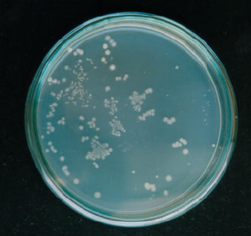

**Fig 4. 2 Crowded Plate Method showing Actinomycetes colonies.**

**4. 3 Characterization of isolates:**

**4. 3. 1 Gram staining:** The organismwas stained and observed to be gram positive rods.

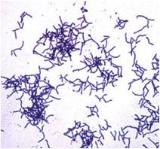

**Fig 4. 3 Gram positive bacteria Actinomycetes .**

**(Source-Actinomycete Cellwww.picswe.com)**

**4.3.2 Taxonomical characterization of isolates:**

Classification of any microbial order is a temporary and manmade arrangement in which similar individuals, sharing certain common features, are grouped together as taxonomic units at different levels in a taxonomic hierarchy. The most stable classifications are likely to be those in which the relationships between taxa are based upon all kinds of data e.g. genetic, phenotic, serologic etc. Taxonomical characterization of six selected soil isolates were done by testing for melanoid formation, nitrate reduction, milk coagulation, and peptonization, gelatin liquefaction, starch hydrolysis H2S production, and carbon assimilation.

**Table 4. 1 Taxonomical Charecterization of isolates**

| Isolates | Melanoid  formation | Nitrate reduction | Proteplytic  activity | Gelatin liquefication | Starch  hydrolysis | Carbon assimilation | Acid  Production | H2S production |
| --- | --- | --- | --- | --- | --- | --- | --- | --- |
| A1 | Light brown | + | Clear with acid reaction | + | + | Glucose | + | + |
| A2 | Only growth | + | Clear with acid reaction | + | + | Glucose | + | _ |
| A3 | Only growth | + | Not clear | + | + | Fructose | + | + |
| A4 | Light brown | + | Not clear | + | + | Lactose | + | + |
| A5 | Only growth | + | - | + | + | Lactose | + | - |
| A6 | Light brown | + | - | + | + | Maltose | + | - |

+ = Positive reaction -= Negative reaction

All the six strains namely A1, A2, A3, A4, A5 and A6 showed positive results in starch hydrolysis and nitrate reduction tests. Strain A1, A4 and A6 showed positive results in pigment production test in Waksman medium (light brown colored pigment) and A2, A3, A5 showed negative results in melanoid formation test but they produced good growth in above said test medium. The six strains showed positive result in gelatin liquefication and H2S production test. The six strains were able to produce the acid in the acid production test. All the strains showed positive results for proteolytic activity except A5 and A6. These physicochemical properties help to differentiate the genus of actinomycetes. Therefore based on taxonomical characterization, A1, A2, A3, A4 were classified under the genus actinomycetes and strains A5 and A6 under the genus nocardia. Among all the isolated strains of actinomycetes, strain A4 showed promising results for an effective antibiotic production which is selected for the further detailed investigation regarding the optimization of fermentation media and large-scale bioprocessing of its antibiotic production. Different carbon sources such as glucose, lactose, maltose, sucrose and dextrose were tested for the source of carbohydrate.

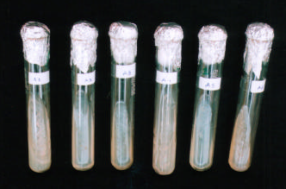

**Fig 4. 4 Melanoid pigment formation in which A1, A4 and A6 showing positive.**

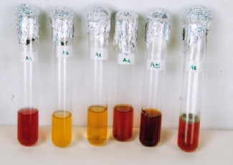 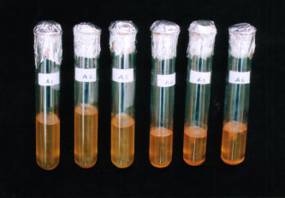

**Fig 4. 5 Nitrate reduction where Fig 4. 6 Gelatin liquefaction test where all**

**all the tubes are showing positive. tubes are showing positve.**

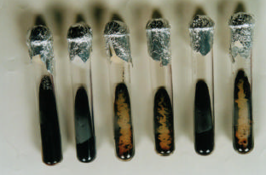 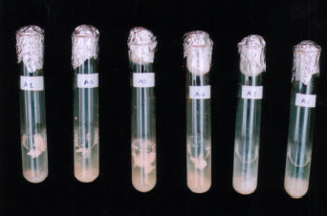

**Fig 4. 7 Strach hydrolysis test where Fig 4. 8 Proteolytic activity where**

**all the tues are showing positve. A1,A2,A3,A4 showed positive results.**

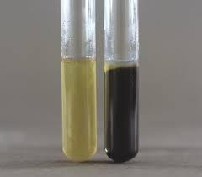 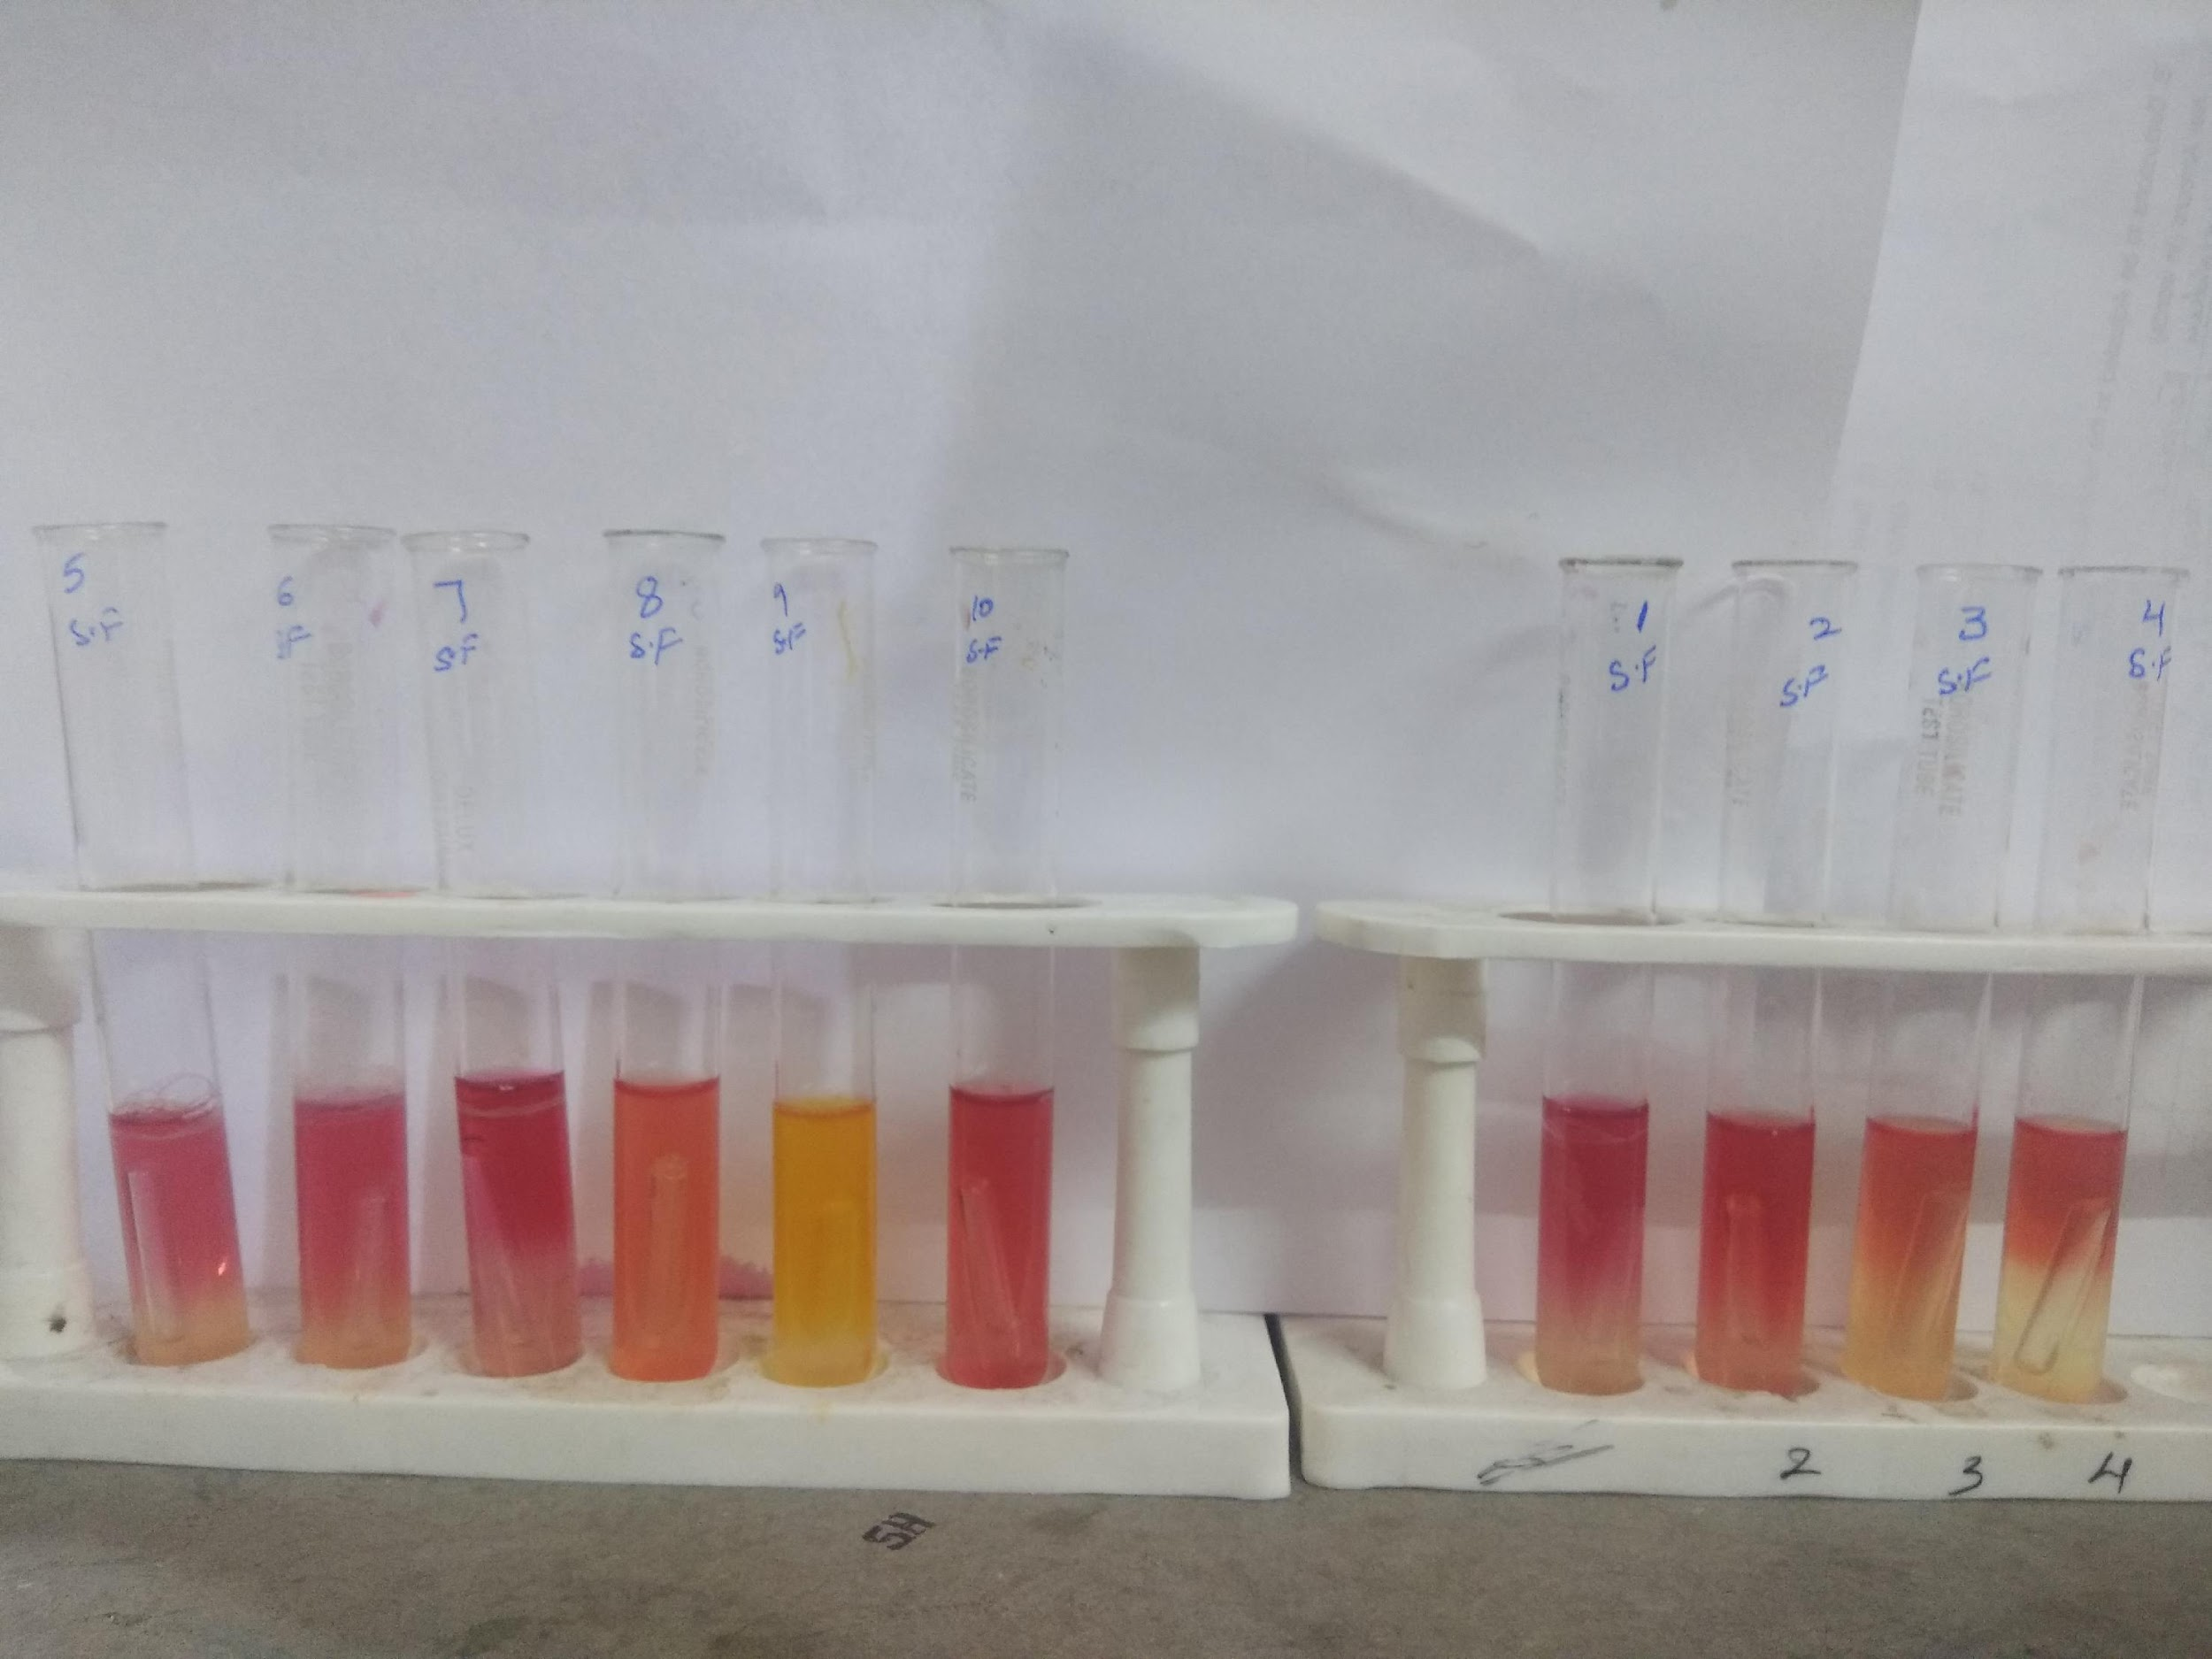 **Fig 4. 9 H2S Production test showing Fig 4. 10 Acid production test where all the a positive and negative result. showing positive result.**

**4. 4 Antimicrobial activity of the crude extract**

The isolated strains of *Actinomycetes* were tested for microbial sensitivity against three bacterial strains and one fungal strains by agar streak method. Out of nine *Actinomycetes* screened, six strains namely A1, A2, A3, A4, A5 and A6 showed significant antimicrobial activity against both gram-positive and gram-negative organisms. However, A4 showed a very broad spectrum with higher scores than all other strains. The *Actinomycete* strains, which showed good inhibition activity was selected and further characterization studies were performed.

**Table 4.2 Sensitivity of different microorganisms towards the isolates by paper**

**dip method.**

| Isolates | *S.aureus* | *E.coli* | *K. pneumoniae* | *S. rolfsii* |
| --- | --- | --- | --- | --- |
| A1 | + | + | - | - |
| A2 | ++ | + | - | - |
| A3 | - | ++ | - | - |
| A4 | ++ | +++ | ++ | + |
| A5 | - | + | + | - |
| A6 | - | + | - | - |

+++ = Better inhibition ++= Good inhibition += Moderate inhibition - = No inhibition

**4. 5 Morphological characterization of postive A4 strain:**

**4. 5. 1 Cultural characterization on ISP mediums:**

The morphological and cultural characteristics of the strain A-4 were studied on International *Streptomyces* Project (ISP) media. The different ISP media used for the morphological study were ISP-1, ISP-3, ISP-4, ISP-5, ISP-6 and ISP-7. The growth characteristics, presence of aerial mycelium and soluble pigments were observed.

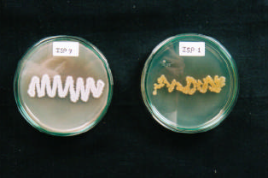 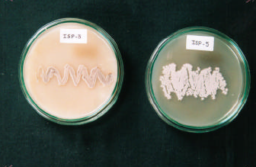

**Fig 4.11 Morphology of A-4 Fig 4.12 Morphology of A-4 Strain on ISP-3**

**Strain on ISP-1 and ISP-7 & ISP-5**

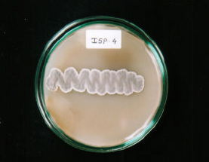 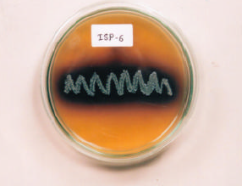

**Fig 4.13 Morphology of A-4 Fig 4.14 Morphology of A-4 Strain on**

**Strain on ISP- 4 ISP- 6**

**Table 4.3 Morphological and cultural charecterization of the strain A4.**

| S.No | Medium Used | A4 |
| --- | --- | --- |
|  | Tryptone yeast extract broth (ISP-1) | Growth occurs by the pellicle formation |
|  | ISP2 | Cream white colored colonies with clear zone around it were observed |
|  | Oatmeal agar (ISP-3) | Slight black- cream color thick colonies were observed |
|  | Inorganic salt-starch  agar (ISP-4) | Blackish-brown colored thick colonies with waxy margin and convex surface was observed. |
|  | Glycerol asparagines  agar base (ISP-5) | Whitish colored thin colonies striated surface; with less aerial mycelium and filamentous growth was observed. |
|  | Peptone yeast extract  iron agar (ISP-6) | Thin transparent colonies with black colored soluble pigments were seen. No filamentous growth was seen. |
|  | Tyrosine agar base  (ISP-7) | Cream colored, lobe shape, convex surface little mycelium growth was observed |
|  | Carbon utilization  agar (ISP-8) | Thin yellowish golden colored colonies with  little mycelium growth were observed |

Morphological characteristics of A-4 strains in different ISP media, showed the filamentous growth in ISP-5 and ISP-7 media and the pigmentation was seen in ISP-6 medium. The morphological characters of strain A-4 were also studied by microscopical observation after Gram-staining method.

The observations revealed that A-4 strain is gram positive and rod shaped microorganism. The microscopical characteristics were observed under 10x and oil-immersion (100x). By studying the morphological, cultural and taxonomical characteristics, it is observed that strain A-4 is belong to the group *Actinomycetes* and genus *Streptomyces.*

**4. 6 Solvent extraction of the antibiotic from A-4 strain:**

The antibiotic was extracted from the strain A4 by using Ethyl acetate as the organic solvent and was purified using the cold ethanol.

**4. 7 Thin layer chromatography:**

Thin layer chromatography of the purified compound was performed. The spots on the plates were developed and observed under UV light at 254 nm and also observed by developing spot with iodine vapors and Rf values are reported. Only one spot was seen after developing TLC plates.

**Table 4.4 Thin layer chromatography of purified antimicrobialcompound.**

| S.No | Solvent Systems | Rf values |
| --- | --- | --- |
|  | Methanol: Acetone (9.2:0.8) | 0.65 |
|  | Methanol: Chloroform (9.4:0.6) | 0.77 |
|  | n-butanol: Acetic acid: Water( 4:1: 5) | 0.87 |

**4. 8 Physical properties of the extracted compound**

**Table 4.5 Physical properties of purified antimicrobial compound.**

| S. No | Physical  Properties | Antimicrobial compound |
| --- | --- | --- |
| 1. | Color | Yellowish cream color |
| 2. | Consistency | White amorphous powder |
| 3. | max | 216 |
| 4. | Solubility | Soluble in water, methanol  Sparingly soluble in DMSO  Insoluble in petroleum ether, ethyl acetate |

**4. 9 Structural identification of antibiotic:**

In an attempt to establish the chemical structure of an antibiotic produced by strain A-4, spectral studies such as IR and NMR were performed and are shown. The basic peak obtained by IR spectroscopical study and their corresponding groups are given in table 4.6. The basic data obtained by NMR spectroscopical study and their corresponding groups are given in table 4.7.

**4.9.1 IR Spectrum of Isolated Antibiotic:**

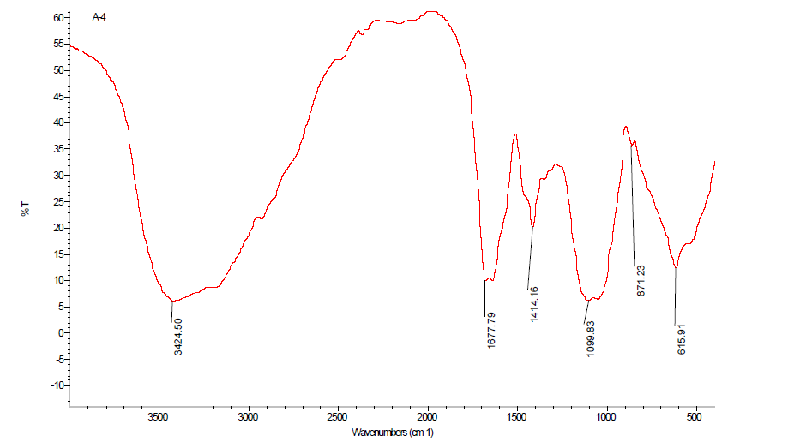

**Fig 4. 15 IR Spectrum for an Isolated Antibiotic.**

The IR spectral studies was done to know the group of the antibiotic produced from A4 strain.

The peak obtained at 3424 corresponds to secondary amines, the peak obtained at 1414 corresponds to alkyl groups and the peaks obtained at 1677,1099,3147 corresponds to aldehydic , alcoholic and aromatic groups respectively. IR- Tracer-100 made by Shimadzu for IR spectroscopy studies.

**Table 4.6 IR Spectroscopical data and their functional groups**

| S.No | Wave number | Functional groups |
| --- | --- | --- |
|  | 3424 | Secondary amines |
|  | 1414 | Alkyl groups |
|  | 1677 | Aldehydic groups |
|  | 1099 | Alcoholic groups |
|  | 3147 | Aromatic groups |

**4.9.2 : NMR Spectrum of Isolated Antibiotic:**

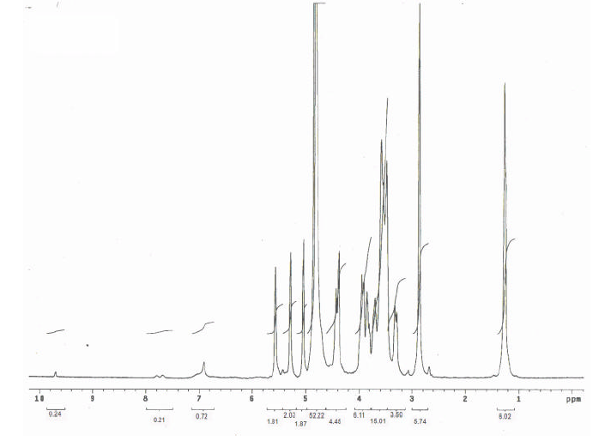

**Fig 4.16 NMR Spectrum for an Isolated Antibiotic**

The NMR spectral studies was done to know the group of antibiotics produced from A4 strain . the peak obtained at 1.24 , 2.86, 3.29, 3.48,3.7. 5.2, 6.9 corresponds to methyl H shift , aldehyde alcohols, esters , alkene, aromatic H or heterocyclic H respectively. From the data of solubility study and spectroscopical studies the isolated antibiotic is classified under the group of macrolides.

**Table 4.7 NMR Spectroscopical data and their functional groups**

| S.No | Peak | Functional Group |
| --- | --- | --- |
| 1. | 1.24 | Methyl H-shift |
| 2. | 2.86 | Methyl H-shift |
| 3. | 3.29 | Aldehyde |
| 4. | 3.48 | Alcohols |
| 5. | 3.7 | Esters |
| 6. | 5.2 | Alkene |
| 7. | 6.9 | Aromatic-H |

**4.10 Anti-microbial activity of the partially purified compound**

**4. 10. 1 Anti-bacterial activity**

Different concentrations of extracted compound were evaluated for *in vitro* antibacterial activity against *Escherichia coli,* *Klebsiella* *pneumoniae* and *Staphylococcus aureus.* The zones of inhibition (mm) exhibited by different concentrations of compound are listed in Table4.8 Where E.coli and K.pneumonia showed maximmun inhibition that is 7mm and 8mm at different concentrations, E.coli at 50µl and k.pneumonia showed at 40µl and 50µl. Staphylococcus showed max inhibition 6mm at a concentration of 50µl.

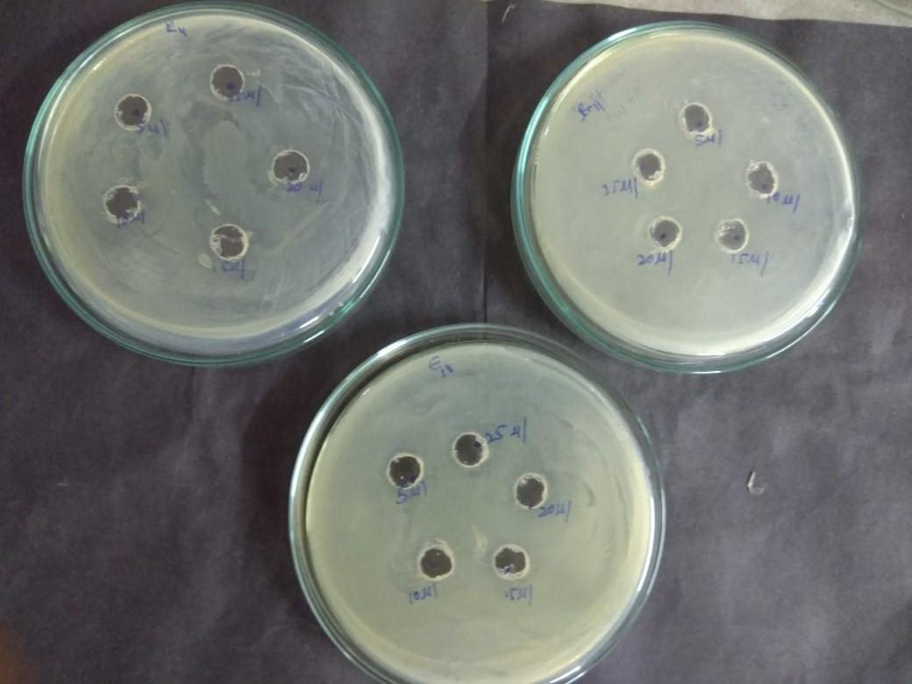

**Fig 4.17 Control plates treated with ethyl acetate showing NO zone of inhibition**

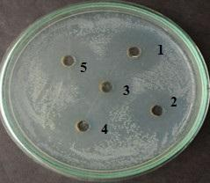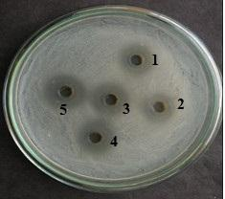

**Fig 4.18 Antibacterial activity of the isolate Fig 4.19 Anti-bacterial activity of the isolate**

**against *E.coli* showing the zone of inhibition. against *k.pneumonia* showing zone**

**inhibition.**

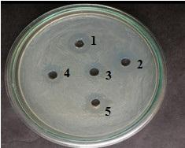

**Fig 4.20 *S. aureus* showing the zone of inhibition.**

**Table 4.8 Antibacterial activity of partially purified compound.**

| S.no | Concentration of compound | *E.coli* | *K.pneumonia* | *S.aureus* |
| --- | --- | --- | --- | --- |
| 1. | 10µl | 2mm | 3mm | 2mm |
| 2. | 20µl | 2mm | 5mm | 3mm |
| 3. | 30µl | 3mm | 7mm | 5mm |
| 4. | 40µl | 5mm | 8mm | 5mm |
| 5. | 50µl | 7mm | 8mm | 6mm |

**4.10.2 Anti-fungal activity** :

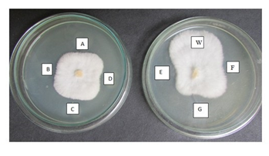

***Fig 4.21 Inhibition on phytopathogen S.rolfsii with different concentration levels of extracted******compound (mg ml-1) [A=0.075, B=0.15, C=0.31, D=0.62, E=1.25, F=2.5, G=5.0 and***

***W = control (water).***

**Table 4. 9 Anti-fungal activity of the partially purified compound.**

| S.No | Concentration | Inhibition percentage |
| --- | --- | --- |
| 1. | 0.075µl | 45% |
| 2. | 0.15µl | 35% |
| 3. | 0.31µl | 40% |
| 4. | 0.62µl | 35% |
| 5. | 1.24µl | 50% |
| 6. | 2.5µl | 20% |
| 7. | 5µl | 50% |
| 8. | - | 0% |

The maximum inhibition was observed at 2 different concentrations that is 1.25µl and 5.0µl

and the inhibition percentage seen is 50%max.

Different isolates of *Actinomycetes* were isolated from hussain sagar lake water and was checked for the antimicrobial activity. The isolate which showed good antimicrobial activity was selected and further studies were performed.

The antibiotic from the selected isolate was extracted by using ethyl acetate as the organic solvent. And again checked for anti- bacterial and anti-fungal activity against the pathogenic organisms like *E. coli*, *K. pneumonia*, and *S.aureus* and *S.rolfsii.*

The structural identification of antibiotic isolated from the strain A4 was done by using IR and NMR spectroscopy. From the data we infer that it belongs to the group macrolide.

**CHAPTER 5**

**SUMMARY AND CONCLUSION**

Screening of antibiotics has been widely performed for about last 50 years and new antibiotics are still being found. In screening of new antibiotics, new approaches are required and following three factors must be considered i.e. detection of antibiotic producing microorganisms, selection of producing microorganisms and cultivation methods. These are closely related to each other, and their efficient combination is essential for successful screening of an antibiotic (C. Edwards M. Dawson, PDA James *et al.,* 1991).

Though the production of antibiotic is sometimes evident during growth of the microorganisms, usually the production is actively carried out after growth reaches stationary phase. The morphological and physiological properties of the strain are greatly changed before and after antibiotic accumulation begins. Particularly trophophase, in which respiration is high and vegetative growth is accelerating by utilizing constituents of the medium. In idiophase, growth stops and antibiotic production reaches at maximum. Thus conditions for antibiotic production are more restricted than the growth conditions, and thus the efficient conversion from the trophophase to the idiophase is important for the production of antibiotics (R. Gesheva, V. Gesheva, V. Ivanova *et al.,*2005).

As the antibiotics are secondary metabolites, they are synthesized in trace amounts in an ordinary fermentation. Moreover the synthesis of antibiotic is regulated by tight metabolic and genetic regulation. Therefore it is the task to the biotechnologists to modify the wild type strain and to provide cultural conditions to improve the productivity of antibiotics (Alfonso Mendoza, Juan Soliveri *et al.,*1988). Improvement of the microbial strain offers the greatest opportunity for cost reduction without significant capital investment. The desired result of strain improvement is the ability of a manufacturing process to meet additional demands without adding more production scale fermenters. With the consideration of above basic criteria, the production of antibiotic using ‘Actinomycetes’ species was studied by initial isolation of actinomycetes strains from water by ‘Crowded Plate Technique’ (Haque SFK, Sen SK, Pal SC *et al.,*1992). From crowded plate, 09 actinomycetes strains were isolated and tested for antibiotic production. According to the antimicrobial spectra against chosen 3 bacteria and 1 fungi, one strain is selected, showing broad spectrum of antimicrobial activity for the further bioprocess studies.

The selected strain is designated as A-4 and its taxonomical characterization is performed. From taxonomical characterization results, A-4 is classified as *Actinomycete.* Then, its morphological, cultural and microscopical characters were studied on various ISP media, which ultimately concluded that A-4 is an *Actinomycete*. ( *Streptomyces*)

When the growth of the microorganisms reached to idiophase, the fermented broth was collected, filtered and centrifuged for separation of cell debris, and supernatant was collected. From the supernatant which is separated from the fermentation broth was subjected to the solvent extraction using various organic solvents like petroleum ether, chloroform, ethyl acetate etc. The cell biomass collected during fermentation broth filtration, is subjected to cell disintegration using sterile sand to check the intra-cellular antibiotics.

In solvent extraction study, same proportion of organic solvent and fermentation broth were extracted. Each solvent was studied, initially, for its antimicrobial properties using cup-plate method. It is found that ethyl acetate is the good solvent for the isolation of antibiotic from fermentation broth as it did not modify the antibiotic and maximum concentration of antibiotic was extracted using ethyl acetate from fermentation of broth as compared to the other organic solvents.

The crude antibiotic from the ethyl acetate was collected by evaporating the solvent at 30°C. The obtained crude antibiotic was purified by using cold methanol. The purified antibiotic in powder form from methanol was collected and its physicochemical properties were determined.

The purified antibiotic showed significant and potent antibiotic activity. The product resembles macrolide group of antibiotics. Efforts to establish the complete structure of the antibiotic is in progress. Optimization of the parameters of the bioreactors and medium formulation helped in increasing productivity of the product in laboratory scale and may help in production scale

Based on the above experimental study, we conclude that :

* Different strains of *Actinomycetes* were isolated from hussain sagar lake water ,out of which strain A-4 was showing better antimicrobial activity in comparison with other water and soil isolates of *Actinomycetes*, which have been investigated.
* The morphological, biochemical studies of strain A-4 showed the characteristic features of the family Actinomycetaceae.
* After the extraction, the antibiotic from the fermentation broth was extracted by using ethyl acetate as an organic solvent and purified by cold methanol.
* The IR and NMR data showed the antibiotic belongs to the macrolide group.

**REFERENCES**

A. Selman,Waksman. The Actinomycetes 1954. *1st edition*, Watham, MASS, USA..

Actinomycetals: Characteristics and practical importance 1973. Edited by G. Syker and FA

Skinner. *Academic Press*, London & New York; 1-91 and 231-247.

Brun YV, Skimkets LJ. Prokaryotic development 2000. *ASM Press*,; p.11-31.

Casida LE. Industrial Microbiology 1984, 3rd edition. Wiley Easter Ltd.,; 3-437.

Egorov NS. Antibiotics – A Scientific Approach 1992. *MIR Publishers*, Moscow,; 62-75 & 132-176).

Erick J. Vandemme. Biotechnology of Industrial Antibiotics 1948. Dekker Series, *Vol. 22, Marcel Dekker Inc.,* New York; 3-42.

Edward G. *Jaff. Bergey’s Manual of Derminative Bacteriology*. 9th edition. WMC Brown Publishers, USA, 712-829.

Haque SFK, Sen SK, Pal SC. Screening and identification of antibiotic producing strains of *Streptomyces* 1992. *Hindustan Antibiotics Bulletin*; (3-4):76-83.12)

Haifeng Hu and Kozo Ochi. Novel approach for improving the productivity of antibiotic-producing strains by inducing combined resistant mutations 2001. *Applied and Environmental Microbiology*; 1885-1892.

JC Ensign, P. Normand, JP Burden and CA Yallop. Physiology of some actinomycete genera 1993. *Research in Microbiology*; 144(8):657-660.

John E. Smith. *Perspective in biotechnology and applied microbiology*. 1989; 105-134.

John Bu’Lock. Basic Biotechnology. *Academic Press*; 425- 448.

JC Ensign, P. Normand, JP Burden and CA Yallop. Physiology of some actinomycete genera 1993. *Research in Microbiology*; 144(8):657-660.

Jun Xu, Haifeng Hu, Noboru Otake and Kozo Ochi. Innovative approach for improvement of an antibiotic – overproducing industrial strain of *Streptomyces albus* 2003. *Applied and Environmental Microbiology*; 6412-6417.

Juan Soliveri, Alfonso Mendoza and Maria-Enriqueta Arias. Effect of different nutrients on the production of polyene antibiotics PA-5 and PA-7 by *Streptoverticillium sp* 43/16 in chemically defined media 1988. *Applied Microbiology and Biotechnology*; 28:254-257.

Penicillins and other antibiotics by Gcos Andrews and J. Miller 1949. *Tood Publishing Group;* 42-51.

ST Williams, R. Locci A. Beswick, DI Kurtboke, VD Kuznetsov, FJ Lemonnior, PF Long. Detection and identification of novel actinomycetes 1993. *Research in Microbiology*; 144(8):653-656.

S. Parekh, VA Vinci, RJ Strobel. Improvement of microbial strains and fermentation processes 2000. *Applied Microbiology and Biotechnology*; 54:287-301

Stanbury PF, Whitaker A, Hall SJ. *Principles of Fermentation Technology* 1995. 2nd edition, Pergamon,; 93-116, 43-65.

S. Chatterjee and LC Vinning. Nutrient utilization in Actinomycetes. Induction of ? glucosidases in *Streptomyces venezuelae* 1981*. Canadian Journal of Microbiology*; 27:639-645

V. Gesheva, V. Ivanova, R. Gesheva. Effects of nutrients on the production of AK-111-81 macrolide antibiotic by *Streptomyces* *hygroscopicus* 2005. *Microbiological Research*; 160:243-248.

William R. Strohl. *Biotechnology of Antibiotic. 2nd edition, Vol.82*. Marcel Dekker Inc., New York, 1-63

Yoshiko Okamoto-Hosoya, Susumu Okamoto and Kozo Ochi. Development and antibiotic-overproducing strains by site-directed mutagenesis of the rpsl gene in *Streptomyces lividans* 2003. *Applied and Environmental Microbiology*; 4256-4259.

Yoshiko Hosoya, Susummu Okamoto, Hideyaki Muramatsu and Kozo Ochi. Acquisition of certain Streptomycin-resistant (str.) mutations enhances antibiotic production in bacteria 1998. *Antimicrobial Agents and Chemotherapy*; 2041-2047.

Yuzura Iwai and Satoshi Omura. Culture conditions for screening of new antibiotics 1981. *Journal of antibiotics*; 25(2): 123-141.

.

**APPENDIX**

1. Nutrient Agar :

| Peptone | 0.5g |
| --- | --- |
| Beef extract | 0.3g |
| Agar | 2g |
| Sodium Chloride | 0.3g |
| Distilled water | 100ml |

2. Potato Dextrose Agar:

| Potatoes (peeled and sliced | 200g |
| --- | --- |
| Glucose (dextrose) | 20g |
| Agar | 20g |

Boil 200g of peeled and sliced potatoes in 500ml distilled water till pieces become soft. Filter the extract through cheese cloth and squeeze gently. Add glucose, agar and make up to 1000ml. Adjust pH to 5.5 and sterilize.

3. *Actinomycetes* Isolation agar:

| Sodium caseinate | 2g |
| --- | --- |
| L- asparagine | 0.1g |
| Sodium propionate | 4g |
| Dipotassium phosphate | 0.50g |
| Magnesium phosphate | 0.15g |
| Ferrous sulphate | 1g |
| Agar | 15g |

4. Tryptone yeast extract:

| Casein enzymic hydrolysate | 6g |
| --- | --- |
| Yeast extract powder | 3g |
| agar | 12 |
| p H | 7.2 |

5. Oatmeal agar:

| Oatmeal | 6g |
| --- | --- |
| Agar | 12g |
| p H | 7.2 |

6. Inorganic salt-Starch Agar:

| Starch soluble | 10g |
| --- | --- |
| Dipotassium phosphate | 1g |
| Magnesium sulphste heptahydrate | 1g |
| Sodium chloride | 1g |
| Ammonium sulphate | 2g |
| Calcium carbonate | 2g |

7. Glycerol Aspargine Agar:

| L-Aspargine | 1g |
| --- | --- |
| Dipotassium phosphate | 1g |
| Agar | 20g |
| Ferrous sulphate heptahydrate | 0.1g |
| Manganese chloride tetrahydrate | 0.1g |
| Zinc sulphate heptahydrate | 0.1g |
| Ferrous sulphate heptahydrate | 0.01g |
| Magnesium chloride 7.H20 | 0.01g |

8. Peptone Yeast Extract:

| Peptic digest of animal tissue | 15g |
| --- | --- |
| Proteose peptone | 5g |
| Yeast extract | 1g |
| Ferric ammonium citrate | 0.5g |
| Dipotassium phosphate | 1g |
| Sodium thiosulphate | 0.08g |
| Agar | 15g |

9. Carbon utilization Agar:

| Ammonium sulphate | 2.6g |
| --- | --- |
| Mono potassium phosphate | 2.3g |
| Dipotassium phosphate 3 H20 | 5.6g |
| Magnesium sulphate 7H2O | 1g |
| Copper sulphate 5H20 | 0.006g |
| Ferrous sulphare 7H2O | 0.01g |
| Manganese chloride. 7H2O | 0.01g |
| Zinc sulphate.7 H2O | 0.15g |
| Agar | 15g |

10. Tyrosine Agar ISP-7 Medium:

| L-Asparagine | 0.5g |
| --- | --- |
| L-Tyrosine | 0.5g |
| Dipotassium phosphate | 0.5g |
| Magnesium sulphate | 0.5g |
| Sodium chloride | 1g |
| Agar | 20g |
| Ferrous sulphate 7 H2O | 1.36g |
| Copper chloride 6H20 | 0.27g |
| Cobalt chloride 6 H2O | 0.40g |
| Sodium molybdate | 0.025g |
| Zinc chloride | 0.020g |
| Boric acid | 2.5g |
| Manganese chloride 4H2O | 1.8g |
| Sodium tartarate | 1.7g |